GitHub webhooks in Jenkins are used to trigger the build whenever a developer commits something to the master branch.

Step 1: Go to git hub repository🡪repository🡪webhook

Step1.1: [http://18.216.86.62:8080/**github-webhook**/](http://18.216.86.62:8080/github-webhook/)

Step : webhook syntax like 🡪Jenkins server url/github-webhook --🡪save the webhook

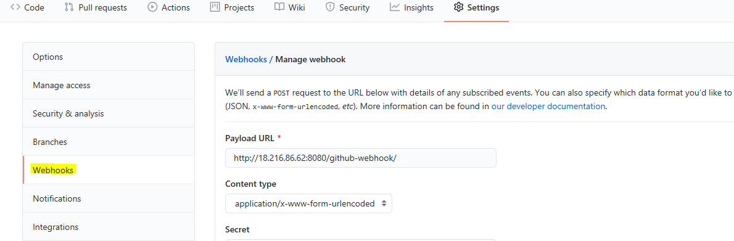

Step : status is green showing below mean web hook is fine.

Note : something error showing delete and re-create the web hook.

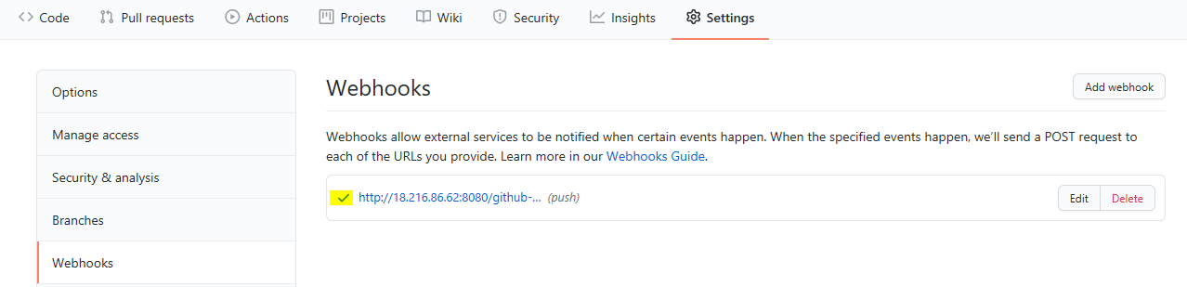

Step:

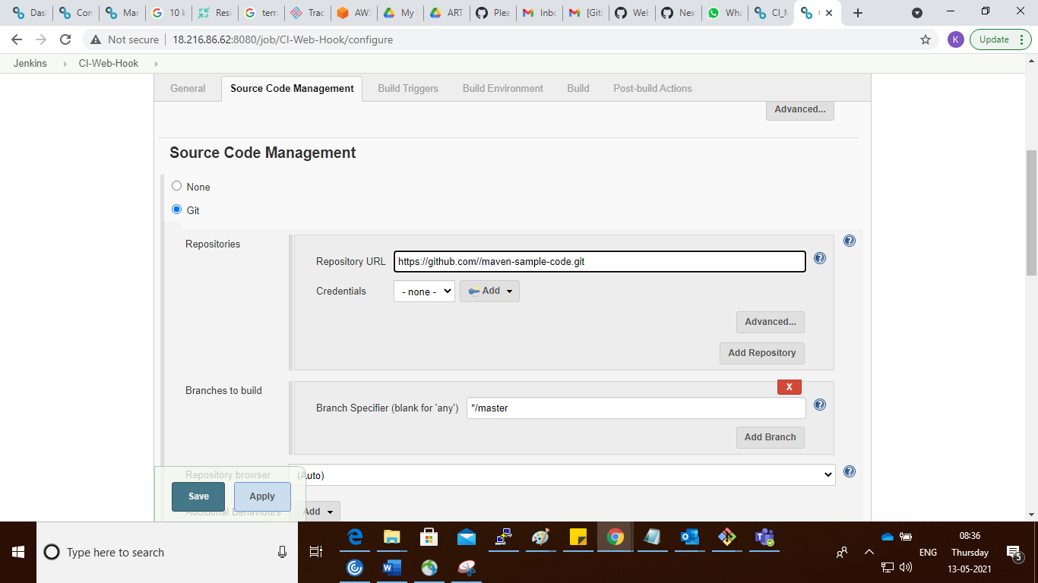

Step : click on the github webhook trigger option in Jenkins job

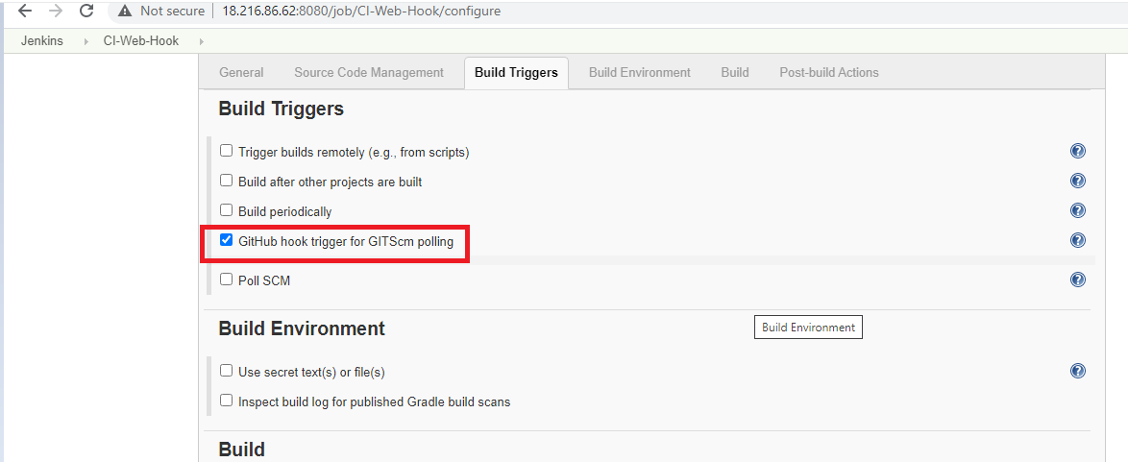

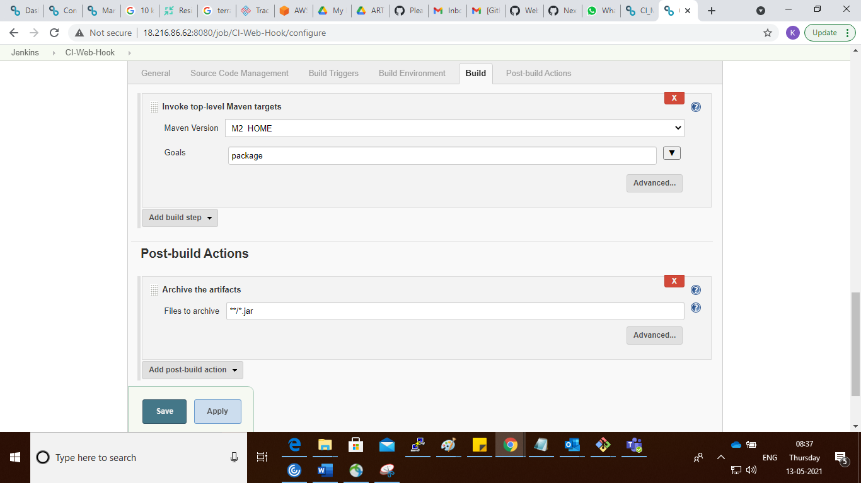

Step : modify the code and push to github repo

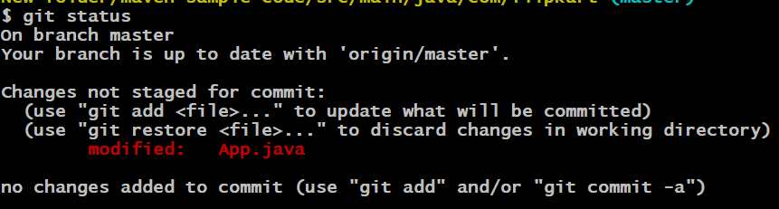

Step4 : check in Jenkins job trigger or not automatically like below

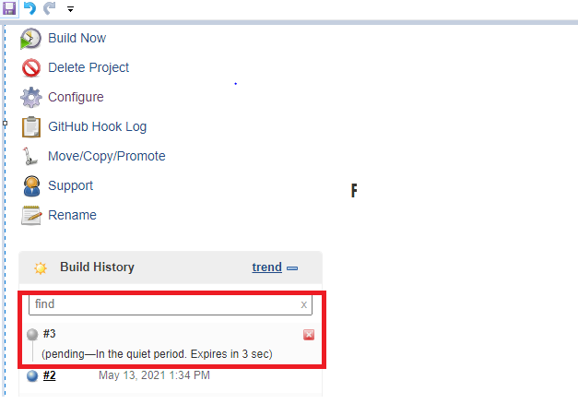

Step 5:

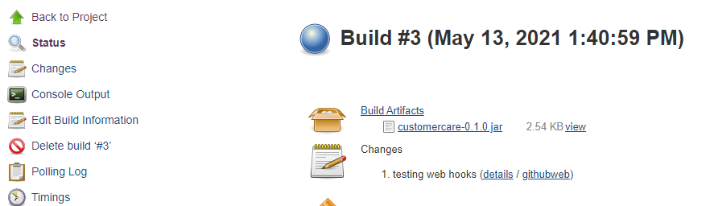

Step 5 :

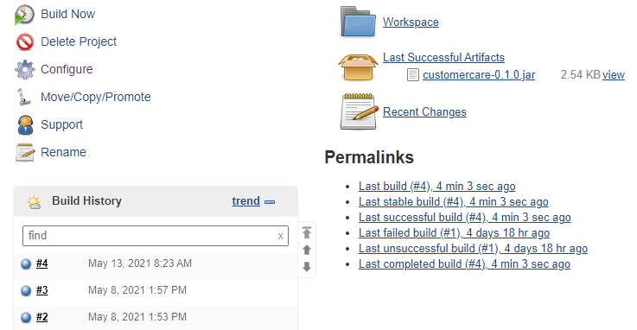

Step : check web hook details

